**CENWP-OD-B18 June 2023**

**MEMORANDUM FOR THE RECORD**

**SUBJECT: 23BON029 MFR WA Shore UMTJ Rest Box Pacific Lamprey Mortalities**

On 18 June, Bonneville Fisheries discovered one adult Pacific Lamprey mortality in Rest Box 2 (UMTJ RB2) of the Washington Shore Lamprey Passage System. The fish was scanned for PIT tags, inspected, and returned to the river.

1. Species – Pacific Lamprey (*Entosphenus tridentatus)*
2. Origin – Unknown
3. Length – 63.5 cm
4. D-G. Marks and tags, Marks and Injuries found on carcass, Cause and Time of Death, Future and Preventative Measures – None or not applicable.

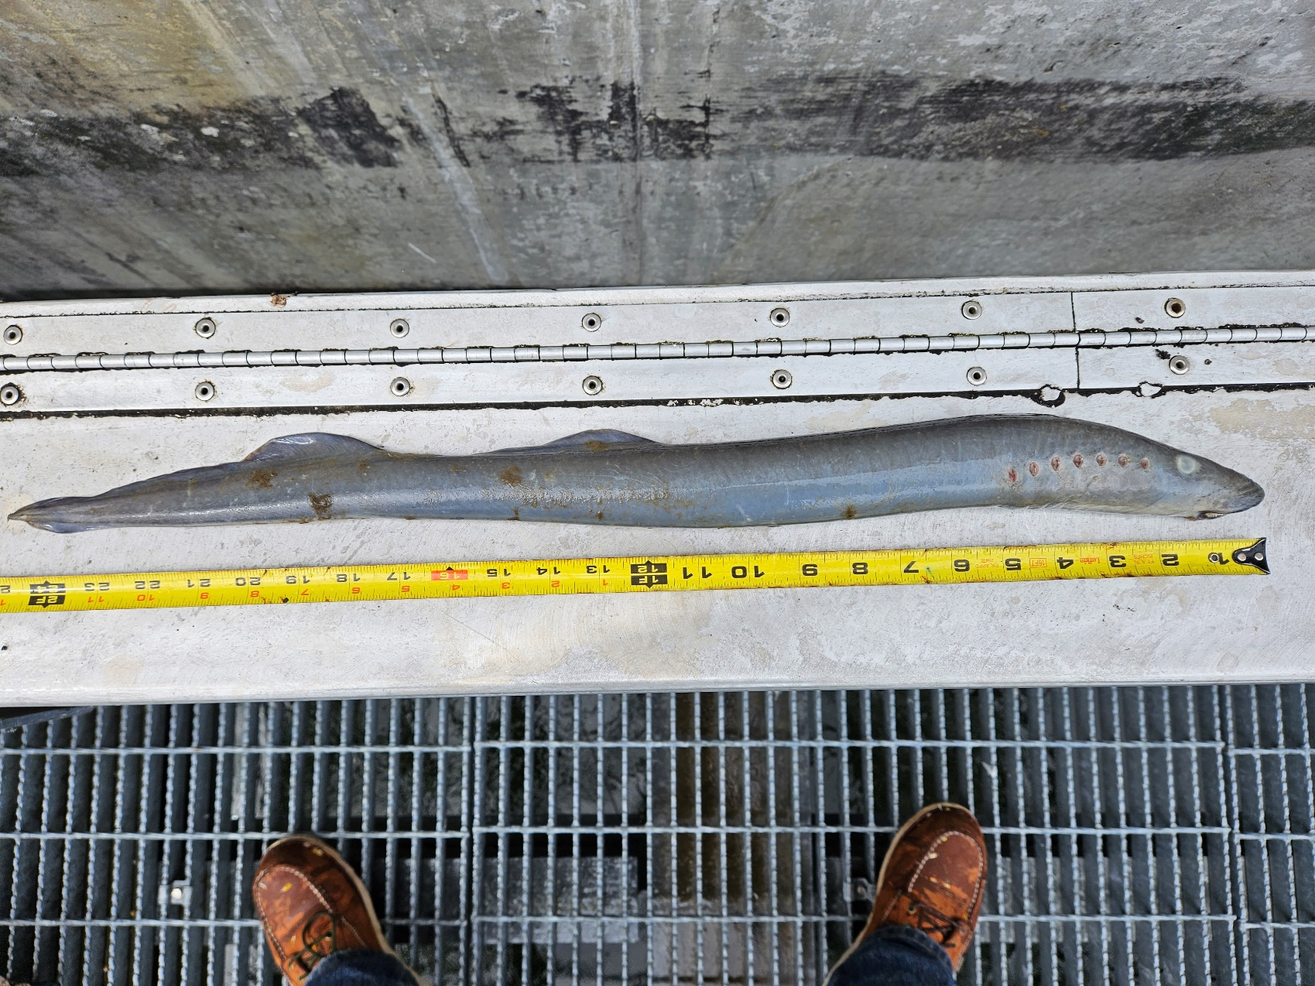

On 18 June, Bonneville Fisheries discovered one adult Pacific Lamprey mortality in Rest Box 5 of the Cascade Island Lamprey Passage System. The fish was scanned for PIT tags, inspected, and returned to the river.

1. Species – Pacific Lamprey (*Entosphenus tridentatus)*
2. Origin – Unknown
3. Length – 67.3 cm

D-G. Marks and tags, Marks and Injuries found on carcass, Cause and Time of Death, Future and Preventative Measures – None or not applicable.

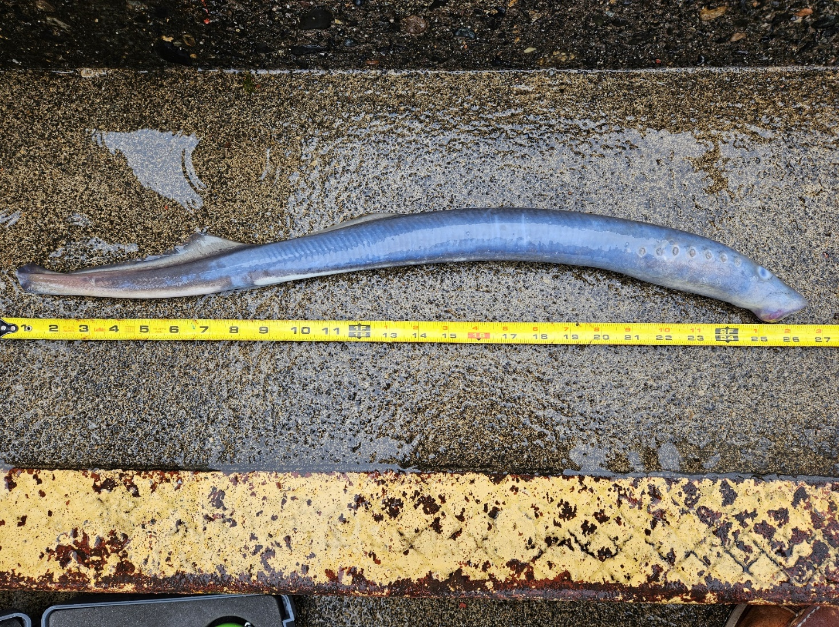

Sincerely,

Bonneville Project Fisheries